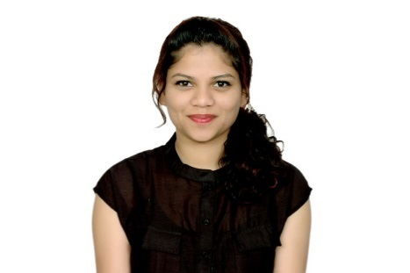
Criselda STEPHANIE Paul
ABU DHABI, UAE

Mob: +971-562721098 | criseldapaul@gmail.com
Personal
Gender: Female
Nationality: Indian
Marital Status: Single
D.O.B.: 24.05.1991
Visa Details: Visit (Until 26th March 2016)

Profile
Team player with exceptional interpersonal and communication skills, and extremely goal-oriented with a keen attention to detail, and the ability to handle pressure.

Area of Expertise
Experienced language professional with strong skills in French and English and Website Management, demonstrating high ownership of various areas of responsibility, especially Customer Service and Training, and possessing strong verbal and written communication skills in English, French and Hindi. Able to work well individually and in a team.

Professional Experience

FRENCH CATALOG ASSOCIATE - Amazon Development Centre, India July 2014 – July 2015

- Procuring and populating content for the product catalog
- Interacted and coordinated with native French, German And UK vendors/buyers to accurately reflect the Amazon catalog for price, product details and other product-related information
- Worked for the Customer Service and Inbound Support Services Teams
- Train new staff and give feedback to the training team
- Be part of client calls to raise challenges, lead, and document conference discussions
- Reviewing all available data and researching missing information
- Ensuring that the website content is accurate and up to date
- Contributing to reducing and solving issues in catalog for optimizing the supply chain process.
- Flag any updates received from stakeholders on the process to Team Lead/Manager
- Understood and correctly used Amazon's Retail Systems Platform(RSP) to support vendors and buyers in enhancing the retail selection on Amazon's online catalog

Education

Pragati Women's College Of Education; Pernem, Goa |

(Affiliated to SNDT University, Mumbai)

B.Ed (Social Science & English) | 79% | May 2014

IGNOU Institute of Distance Learning |

M.A. (English) | (Currently Pursuing)

Goa University; Talegao Plateau, Goa |

M.A (French) | 81% | May 2013

St. Xavier's College; Mapusa, Goa |

B.A (Mass Communication & Videography) | 74% | May 2011

Internships
- Intern, St. Theresa's High School, Goa | 25th Nov - 7th Dec 2013
Conducted regular classes, remedial classes and drills at high school level for classes 6 and 7.
- Intern, St. Joseph's High School, Goa | 15th - 30th Sept 2013
Conducted regular classes, remedial classes and drills at high school level for classes 6 and 7.
- Intern, Prasad Pankar Photography, | May 2012
Assisted with a photo-shoot for International singer Belinda Carlisle’s Fashion accessory website, with renowned Fashion Photographer Prasad Pankar.

Skills
Languages (written and spoken): English, French, Hindi & Konkani
Microsoft Office: MS Word, MS Excel, MS PowerPoint
Teaching methodologies
Video-editing (have previously video-edited local news channel broadcasts as part of curriculum)
Proof-reading magazines and novels
Voice overs and sub-titling TV Shows etc. (have previously sub-titled documentaries and given voice-overs as part of curriculum)

Activities
Winner of the West Zonal Essay Competition organised by UNICEF in 2013
Finalist at UNINOR's All India "Idea Hunt" competition (Apps for a social change) in New Delhi, India in 2013 (Top 6)
Participated in various elocution and debate competitions at the High School level
Won 3rd place at a National Level French singing competition, and participated in several College level singing competitions
Excelled with a distinction at the Australian Macmillan examinations in English at the high school and higher secondary school level
Attended a French training program in French Phonetics organised by Alliance Française in September 2012
Attended the International Association of Teachers of French (IATF) Conference in Chennai, India in 2014
Hobbies
Writing poetry, essays
Reading, Singing, Karaoke
Travelling to new places
Playing Badminton

