1099 vs W2 Employee: How Are They Different?

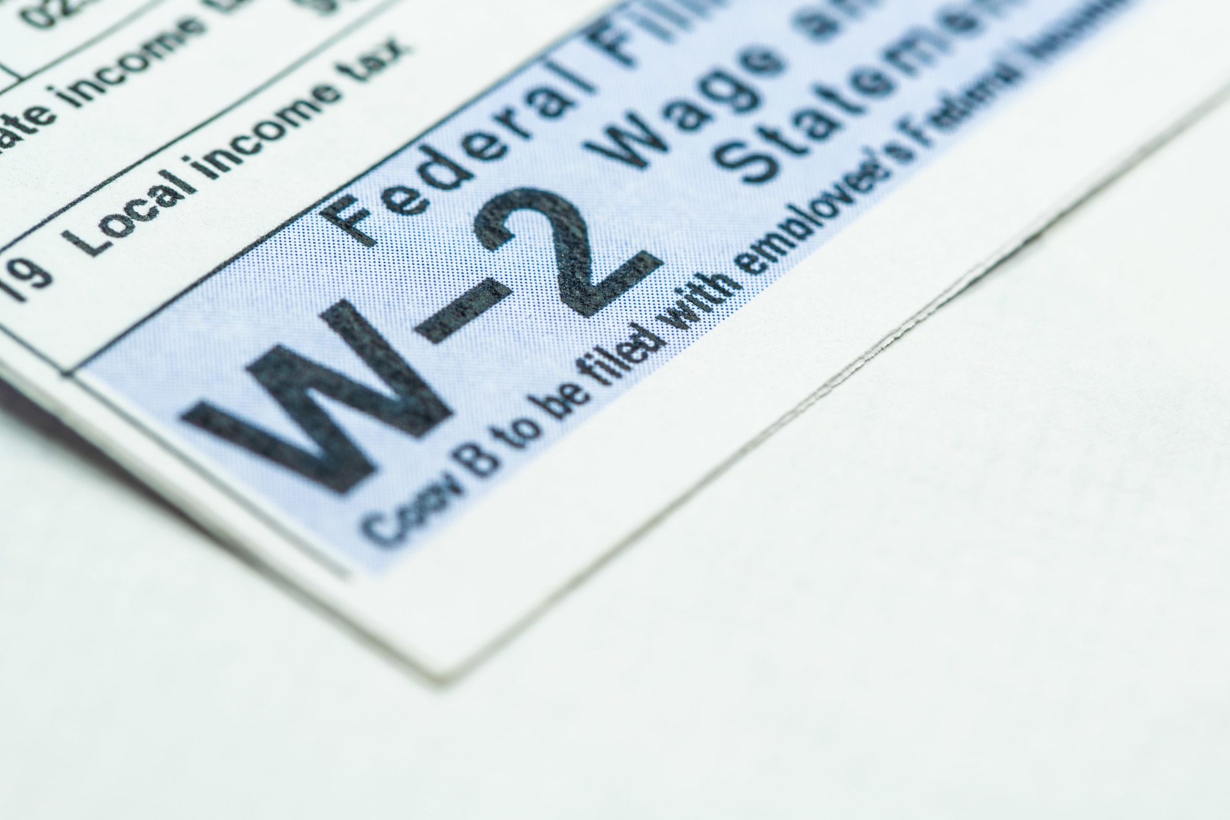

Are you trying to figure out how employees are different? Read this article to learn more about 1099 vs w2 employee differences.

Keyword(s): 1099 vs w2 employee

Anchor Text: Form W2 Creator

What is the difference between 1099 vs W2 Employee? The obvious and quick answer is that the former is an independent contractor, with the latter being a part-time or full-time employee.
But do you know the difference between these two tax forms? Do you know what obligations you, as an employer, have to give these workers? If you don't, then you need to! Choosing whether to hire someone as a 1099 vs W2 employee makes a huge difference to your company.
Read on to learn about these crucial differences:
1099 vs W2 Employee
As stated above, a 1099 employee is an independent contractor. A W2 employee is a part-time or full-time employee. The independent contractor has their hours negotiated with the employer or could be given work on a 'meet the deadline' basis, without regard to how many hours worked.
The W2 employee who is full-time is hired on the agreement that they are entitled to 40 hours per week. The part-time employee is hired with the agreement that they can work as much each week, as long as it does not reach or exceed 40 hours.
These are the basics, but it goes a lot further:
Taxes
A 1099 employee is responsible for their own taxes. You do not have to withhold their taxes from their earnings. The 1099 form which you do provide will only report their overall earnings for the tax year. They are responsible for paying their taxes directly to the IRS, in addition to filing their return.
A W2 employee will have their taxes withheld by their employer. While they still have to file a tax return, their income tax, medicare, and social security tax are to be withheld from each payment. As a result, the W2 form is more detailed. If you hire a W2 employee, make sure that your accounts department is well-versed in this form. You can also use this Form W2 Creator to make things easier.
Obligations
A huge difference between these two types of employees is the obligations the employer owes them. These are the obligations which W2 employees are owed which 1099 employees are not owed:
- Health insurance (if full-time), 401K benefits, time-off
- Overtime pay
- Workspace (i.e., they have an office or desk at the workplace)
- A set schedule (how many hours do they work, etc.)
1099 employees usually work on their own and are responsible for providing their own workspace and any necessary equipment (such as a laptop and internet connection).
1099 employees are also often hired for temporary work such as for seasonal duty or for working on a particular project.
Hire The Right Fit
Now that you know the main differences between 1099 vs W2 employees, you are ready to make that hire!
Make sure you consider this carefully beforehand. If you just need a temporary project, then perhaps a 1099 employee is the way to go. But what if you want a full-time worker who will stay committed to your company? What if you are a startup and you want someone to grow within your company? Then a W2 employee is the best route.
Read more of our articles for more information on running your business!

